CANDIDATE INFORMATION

[UTRC-UCC-SFI Research Fellowship]

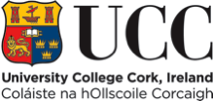

**CONTENTS**

**Information for Candidates**

1. Welcome from the President

1. About Cork

1. University College Cork
2. University Strategic Plan
3. University Organisational Structure

1. Information on the School / Department – **www.cs.ucc.ie**
2. Job Description
3. Equality of Opportunity Statement
4. Housing, Education, Medical Insurance & Tax Information
5. Useful Web Links

**Additional Information for Shortlisted Candidates**

1. Interview Format
2. Directions to UCC
3. Expenses for Candidates Attending for Interview
4. Campus Maps

1. **WELCOME FROM THE PRESIDENT**

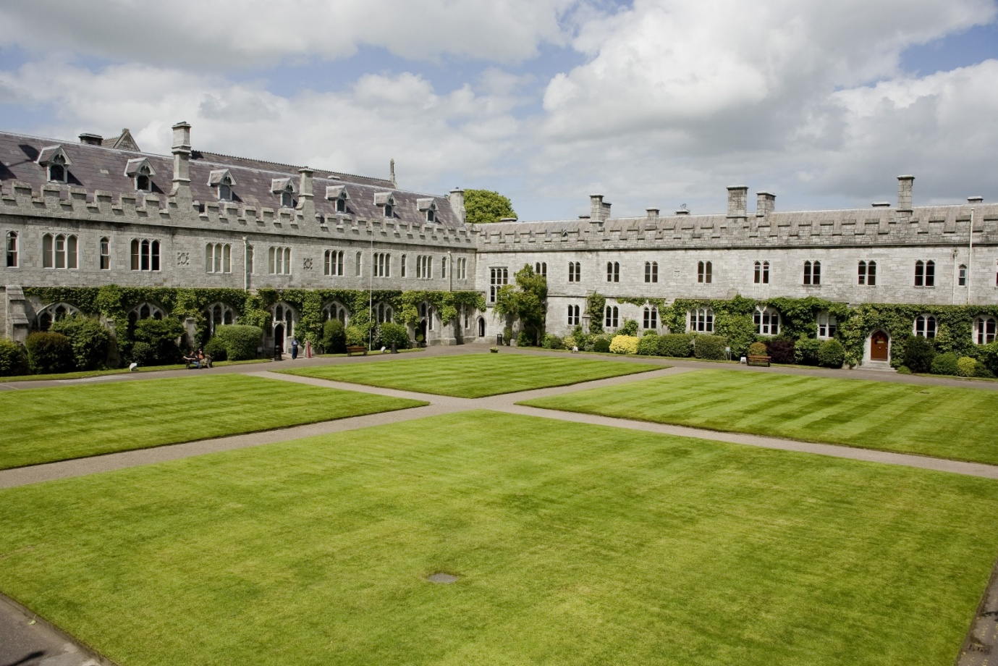

Now that you are considering a career at University College Cork (UCC), let me thank you for your interest and introduce you to our University.

Originally founded in 1845 as "Queen's College Cork", UCC is one of Ireland's oldest institutions of higher education. Ranked in the top 2% of universities worldwide, UCC was named as Ireland’s *Sunday Times* University of the Year in 2011, the third time in 10 years to receive this designation. In 2011, UCC became Ireland’s first Five Star University (under the QS ranking system) and was named the World’s First Green University Campus (Federation for Environmental Education, Copenhagen).

UCC boasts a spectacular campus in a compact university situated in a global tourist destination. The University serves a community that is both local and global. We are a comprehensive, multi-disciplinary university. During our 160 year history, staff or students here have invented the logic on which computer programming is based (George Boole, Professor of Mathematics 1849-54), discovered the cause of the tropical disease, leishmaniasis (Charles Donovan, medical student during the 1880’s) invented the world’s first junction-less transistor (Professor Jean-Pierre Collange, 2010) became Supreme Court Judge (Liam McKechnie, 2010) and much more. We have nurtured composers, poets and playwrights. We have taught over 100,000 alumni who lead and serve society throughout the world.

Today, UCC’s student body of some 20,000 includes over 2,800 from 100 countries across all continents. We employ 2,700 professionals. Over one third of our academic staff have come from overseas. We enjoy many accolades as a high quality employer. The true strength of our university lies in the people who work and study here. The diversity of our workforce and our students is our competitive edge in realising our mission to “*create, preserve, and communicate knowledge and to enhance intellectual, cultural, social and economic life locally, regionally and globally*.”

Our vision - UCC a contemporary Irish University with a global outlook will, I trust, prove attractive to you. This briefing pack contains information which I hope will be useful and informative should you be selected to attend for interview here in Cork.

I trust that your experience of our recruitment process will be a positive one and I thank you, again, for considering a career at University College Cork.



[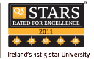](http://www.topuniversities.com/qsstars/ireland)

Dr Michael Murphy

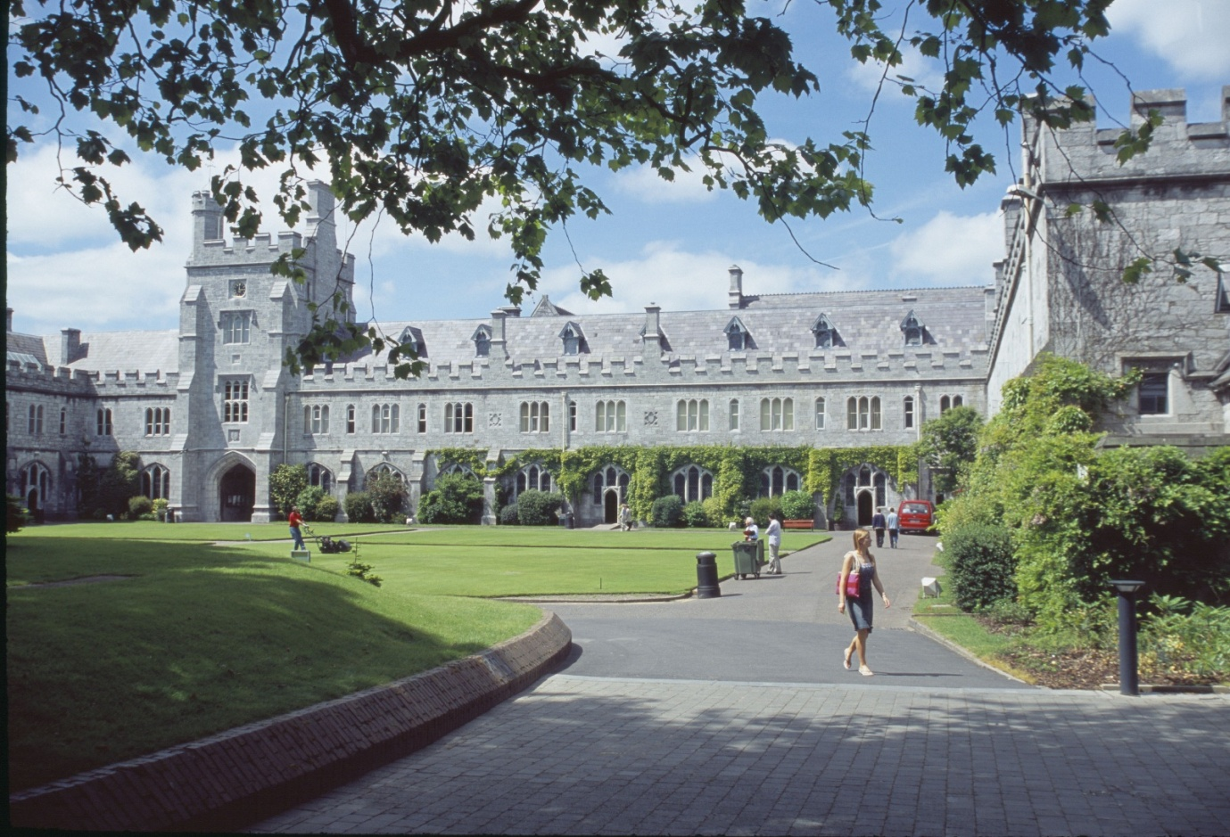

1. **ABOUT CORK**

Recently identified as one of the top ten destinations to visit by the Lonely Planet guide, Cork is a place not just to visit, but to live; offering a quality of life and an academic and cultural experience which reflects positive Irish values. Cork city has a population of some 150,000, with a further 100,000 in the city’s hinterland. Further details can be found at [**http://www.corkcity.ie/**](http://www.corkcity.ie/)

1. **UNIVERSITY COLLEGE CORK [UCC][1][2]**

UCC was established in 1845 as one of three Queen’s Colleges at Cork, Galway and Belfast.  The site chosen for the college is particularly appropriate given its connection with the patron saint of Cork, St Finbarr.  It is believed his monastery and school stood on the bank of the river Lee, which runs through the lower grounds of the University.  The University’s motto is ‘Where Finbarr Taught, let Munster Learn.’ University College Cork (UCC) is the principal university in the province of Munster and the largest outside Dublin

UCC, which has a current enrolment of close to 20,000 students, provides over 120 degree and professional programmes through some 60 Disciplines and offers a research-led curriculum that attracts the highest calibre of students. UCC attracts a large number of international students currently in excess of 2,800.

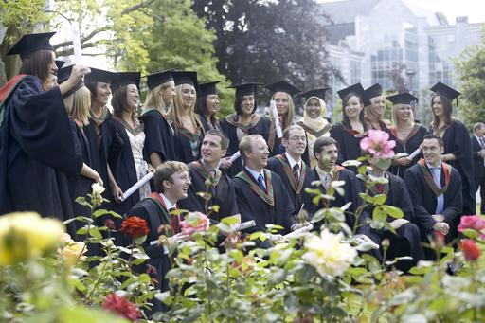

The University offers an innovative, research-led curriculum, taught by world-class academics that consistently attracts a quality student intake. The University has a recurrent budget of €280 million. UCC has established four Colleges to enhance the University’s research and teaching efforts:

* + Arts, Celtic Studies and Social Sciences
  + Business and Law
  + Medicine and Health
  + Science, Engineering and Food Science

Colleges are managed by Heads of College and supported by College Managers, Financial Analysts, HR Managers as well as dedicated administrative support. College-level committees are aligned to Academic Council Committees to enhance decision making, policy implementation and information flow.

UCC employs some 2,700 staff. UCC is committed to building its capacity to carry out research of the highest international quality, and to providing research-lead teaching across the breadth of disciplines and specialisms typical of a traditional university. UCC also prides itself on close connections with the professions, industry and the local community. Further information on UCC including information on Academic and Administrative Departments can be found on the UCC web site. The UCC home page address is www.ucc.ie.

The University budget is in the order of €280m. The University is directly funded by the Higher Education Authority (HEA), receives grant, fees and other income, and also generates levels of research income which for many years have been the highest in the State (in 2010-11 €80m). The University budgetary strategy continues to focus on decreasing its reliance on Exchequer income and promoting income generation through increasing post graduate and international fee income.

UCC consistently delivers a globally significant contribution in research and in teaching and learning, which has secured the University a place in the top 2% of Universities worldwide in the QS World University Rankings (2010). UCC is committed to building its capacity to carry out research of the highest international quality and to providing research-led teaching across the breadth of disciplines and specialisms typical of a traditional university. UCC was the first Irish university to conduct an institution-wide research quality review in 2009.

The University has benefited very substantially over the past ten years from national programmes aimed at developing research infrastructure, capacity and output, mainly funded through the National Development Plan and in line with the Government’s Strategy for Science, Technology and Innovation. It has in this way developed its key role in plans for the long-term economic and social development of the region and the country, the city of Cork being a primary gateway in Ireland’s Spatial Strategy. These developments have also been substantially supported through private funding raised by the University.

The University contains a number of highly prestigious research centres including the Alimentary Pharmabiotics Centre – [**www.ucc.ie/research/apc**](http://www.ucc.ie/research/apc) and the Tyndall National Institute. See [**http://www.tyndall.ie/**](http://www.tyndall.ie/)

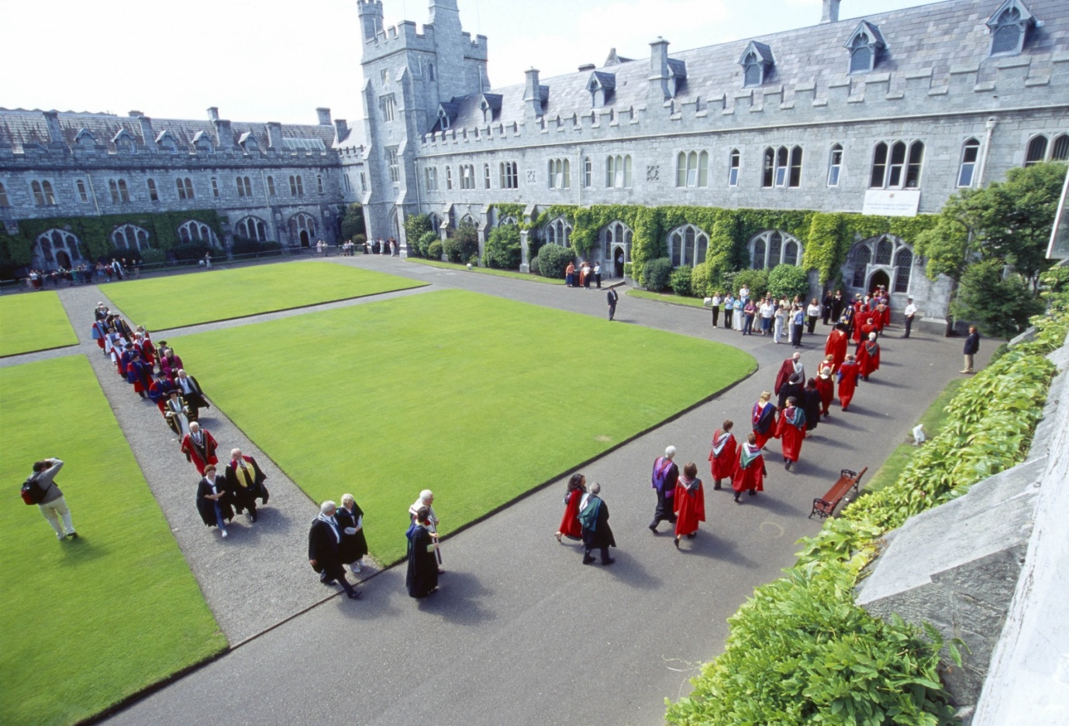

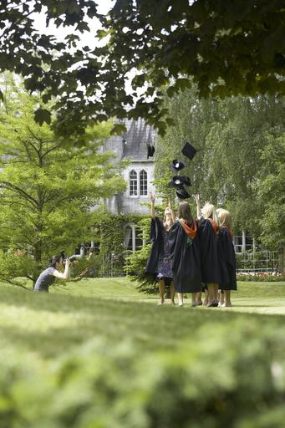

The functions of the University are performed under the direction of the Governing Body. The Academic Council, subject to the financial constraints determined by the Governing Body and to review by it, controls the academic affairs of the University. The main executive management group is the University Management Team, which works in support of the President.

University College Cork (UCC) has been selected as Ireland’s University of the Year 2011/12 by *The Sunday Times.* This award has been given for a number of reasons which include recognition of the University’s position as the leading research institution in Ireland; the University’s cosmopolitan character which encompasses an admirable student mix; the excellence of UCC’s teaching and academic standards and the University’s links with business and industry.

The *Sunday Times* award, which is the third occasion UCC has received this award, follows on the heels of UCC becoming the only Irish university to achieve the unique status of Ireland’s first five star university.

UCC is also the first university campus to be awarded the Green Flag for an environmentally friendly campus in a student-led innovation. UCC is proud of its achievement as the world’s first university to achieve the ISO 50001 standard in energy management systems

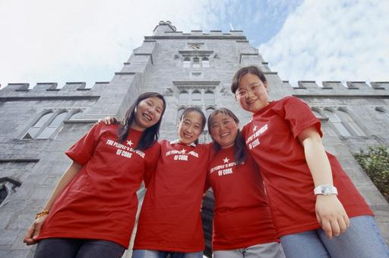

**Tours of the University & School/Departmental Visits**

A virtual tour of UCC is available on [**http://www.ucc.ie/en/visitors/see-do/**](http://www.ucc.ie/en/visitors/see-do/)

For some positions, you will also be offered an opportunity to tour the relevant department/school.

1. **UNIVERSITY STRATEGIC PLAN**

Details of the UCC Strategic Plan can be found on [**http://www.ucc.ie/en/strategicplanning/strategic/**](http://www.ucc.ie/en/strategicplanning/strategic/)

1. **UNIVERSITY ORGANISATIONAL STRUCTURE**

Governing Body

President

Academic Council

Arts Celtic

Studies &

Social Sciences

Science

Engineering &

Food Science

Medicine

&

Health

Business

&

Law

Registrar

Senior VP

Academic

Bursar

&

CFO

Academic Secretary

VP

Research &

Innovation

VP

Teaching &

Learning

Head

Student

Experience

-School of Applied Psychology

-School of Applied Social Studies

-School of Asian Studies

-School of Education

-School of English

-School of History

-School of Geography & Archaeology, Human Environment

-School of Irish Learning

-School of Languages, Literature & Cultures

-School of Music & Theatre

-School of Sociology & Philosophy

-School of Asian Studies

-Classics

-Study of Religion

-Computer Science

School of Mathematical Science

-Biological, Earth & Environmental Sciences (BEES)

-Engineering

-Food Science

-Chemistry

-Physics

-Biochemistry

-Microbiology

-School of Medicine

-School of Dentistry

-School of Nursing & Midwifery

-School of Clinical Therapies

-School of Pharmacy

-Accounting Finance

And Information Systems

-Economics

-Food Business & Development

(Centre for Cooperative Studies)

-Government

-Management & Marketing

-Centre for Policy Studies

-Law

Director

Quality

Promotion

Corporate

Secretary

&

Dir. HR

Director

Inf Services

& Librarian

Director

Estates &

Infrastructure

Director

Planning &

Inst Research

VP External

Relations &

Development

**COLLEGES**

1. **Department of Computer Science – www.cs.ucc.ie**
2. **JOB DESCRIPTION**

**Project Title: UTRC-UCC-SFI Research Fellowship**

University College Cork (UCC), in partnership with United Technologies Research Centre (UTRC) and Science Foundation Ireland (SFI), present an opportunity for a Research Fellow in one of the areas of ultra-high reliability, low bandwidth, energy-aware wireless systems; cognitive or “white space” communication technologies; free-space optical communications; distributed sensing and control, or security and resilience in wireless sensor networks. UCC occupies a unique place in the history of Computer Science. Boolean algebra, which provides the mathematical basis for computer design, was named after George Boole, UCC's first Professor of Mathematics, who wrote his famous “Laws of Thought” while at the university. Today, the Department of Computer Science is one of the largest academic units in UCC. It provides world-class facilities for teaching and research. Further, UCC researchers are internationally recognised for their leadership in several areas, including artificial intelligence, distributed computing, networking, and security.

UTRC, the central research organization of United Technologies Corporation (UTC), has provided funding to UCC to establish an endowed fellowship in the Department of Computer Science. The fellowship exemplifies UTRC’s commitment to support Science, Technology, Engineering and Mathematics (STEM), following similar investments in Stanford, Caltech, Carnegie MellonUniversity, ETH Zurich, RWTH Aachen, and Tsinghua University.

UTRC delivers advanced technologies to the businesses of United Technologies to improve the performance, energy efficiency and cost of UTC products and processes. UTC is a diversified companythat provides a broad range of high-technology products and services to the global aerospace and building systems industries. Its commercial businesses are Otis elevators and escalators and UTC Climate, Controls and Security, a leading provider of heating, ventilation, air conditioning, fire and security systems, building automation and controls. UTRC’s aerospace businesses are Sikorsky aircraft and the new UTC Propulsion and Aerospace Systems, which includes Pratt & Whitney aircraft engines and UTC Aerospace Systems aerospace products.

UTRC partners with United Technologies business units and external research organisations to expand the boundaries of science and technology through research and innovation, delivering technology options that meet and anticipate the needs of the marketplace. Founded in 1929, UTRC is located in East Hartford, Conn., with an office in Berkeley, Calif., and research and development centres in Shanghai, China, and Cork, Ireland. Learn more at: www.utrc.utc.com.

Science Foundation Ireland offers a range of funding schemes which support scientists and engineers to create both research excellence and impact. Full details are available on the SFI website: www.sfi.ie.

Shortlisted candidates for this position will be required, as part of the recruitment process, to apply to SFI. Appointment to the position is contingent on an offer of funding under the SFI Partnership Programme and successful applicants will hold the title of UTRC-SFI-UCC-Research Fellow. The successful candidate will be expected to have a significant track record of research accomplishments, e.g. top-tier international publications and research funding success. The successful candidate will be supported in establishing his/her own research group with the Department of Computer Science at UCC, collaborating with existing groups, as appropriate. The candidate will also have the opportunity to interact closely with research staff at UTRC.

**Post Duration:** Post Duration: 3 Years initially (continuation for a further 2 years thereafter is subject to a successful review in Year 3).

Appointment to the position is contingent on an offer of funding under the SFI Partnership Programme and successful applicants will hold the title of UTRC-SFI-UCC-Research Fellow.

**Salary:** Research Fellow Salary Scale: €51,716 - €56,442

*(New appointments will generally be at the minimum (1st point) of the relevant scale.)*

**Research Fellow**

The Research Fellow title would be awarded to individuals who have personally secured their own independent external research funding inclusive of their salary following an open, transparent and competitive selection process by the research funding body or who have been appointed by the Higher Education Institution following an open competition. The Research Fellow would be associated with a Principal Investigator who would act as his/her mentor and facilitate access to research infrastructure.

The role also allows the Research Fellow the professional development opportunity to demonstrate the capacity for independent and self-directed research and scholarship and the management of a research team. The role allows the Research Fellow to assemble a portfolio of independent achievement and render himself/herself competitive for tenured academic positions or senior scientific roles in industry.

**Key duties and responsibilities**

* To manage and conduct a specific programme of research and scholarship.
* To independently identify research objectives and potential funding sources and to prepare and write bids for funding proposals.
* To have a strong track record in securing external funding, including own salary.
* To disseminate the outcomes of the research, including peer-reviewed academic publications of international standing.
* To take a leading role in the further development of the research programme and in seeking and pursuing appropriate external funding.
* To participate fully in the wider research and scholarly activities of the Research Centre, School and College.
* To have some teaching and mentoring duties.
* To supervise post graduate research students as supervisor or co-supervisor, as appropriate.
* To mentor and assist students and early-stage researchers in the research group, School and College.
* To take responsibility for, manage and conduct administrative and management tasks associated with the research programme.
* To engage in appropriate training and professional development opportunities as required by the Principal Investigator, School or College.
* To carry out any additional duties as may reasonably be required within the general scope and level of the post.

**Selection Criteria**

* A Ph.D. qualification and significant relevant research experience.
* The capacity to work independently on research projects.
* The ability to assess and evaluate concepts/theories in order to develop original solutions and particular knowledge of, and expertise in, research methodologies.
* Track record of high-quality peer reviewed publications.
* Experience in post graduate and Post-Doctoral supervision.
* Strong project management experience.
* Ability to provide leadership to small research teams.
* Ability to secure independent external research funding.
* Ability to contribute to broader organisational and management processes.
* Knowledge transfer and commercialisation experience is highly desirable.

1. **EQUALITY OF OPPORTUNITY STATEMENT**

University College Cork is an equal opportunities employer actively working towards full equality of opportunity in all aspects of University life.

1. **HOUSING, EDUCATION, MEDICAL INSURANCE AND TAX INFORMATION**

**Housing**

**Renting in Cork**

Houses - family homes €750 to €1,400 per month depending upon quality and location.

Apartments - €600 to €1,200 per month. The best source of information for people seeking to rent accommodation are Letting Agents, Auctioneers, National and Local Press.

A selection of Cork Auctioneers is listed below:

O’Mahony Walsh & Associates Tel: 021 4278606

James G. Coughlan & Assoc. Tel: 021 4251500

Sherry Fitzgerald Tel: 021 4273041

**Buying and Renting Property in Cork**

Information on renting and buying a property in Cork can be found on the following websites:

Staff accommodation pages on the UCC Accommodation and Student Activities webpages

[**www.ucc.ie/services/asa/**](http://www.ucc.ie/services/asa/)

Comprehensive Irish Property websites for sales and lettings

[**www.daft.ie/**](http://www.daft.ie/)

Cork based auctioneers, estates agents and property management company

[**www.choices.ie**](http://www.choices.ie)

Residential lettings and sales

[**www.sherryfitz.ie**](http://www.sherryfitz.ie)

Irish Auctioneers & Valuers Institute (IAVI) - Site containing a comprehensive listing of property and real estate from a selection of IAVI members.

[**www.ipav.ie**](http://www.ipav.ie)

Irish property News - Online publication providing property listings and information relating to buying a property in Ireland.

[**www.irishpropertynews.com**](http://www.irishpropertynews.com)

Property website and home portal providing property, services, home and garden products and online mortgages.

[**www.myhome.ie**](http://www.myhome.ie)

**Education– Schools in Cork**

There are several excellent schools in Cork City, located near the University, primary and post primary. The Department of Education, Communications Section, Dublin will provide further information on any queries in this connection Tel +353 1 8896400. The Department of Education also have an Inspectors Office in Cork +353 21 4906011



**Medical Insurance**

There is no state run statutory medical insurance scheme in Ireland. Hospital medical treatment is generally speaking, free while visits to general practitioners cost around €60 each and all prescription medicines must be paid for. However many people choose to avail of private medical insurance to cover the cost of upgraded hospital treatment and to avoid sometimes lengthy waiting lists. There are three established medical insurance companies active in Ireland at present as follows:-

**VHI -** [**www.vhi.ie**](http://www.vhi.ie)

**Laya Healthcare -** [**www.layahealthcare.ie**](http://www.layahealthcare.ie)

**Aviva Health Insurance - [www.avivahealth.ie](http://www.avivahealth.ie)**

These companies offer tailor made health care plans which can be selected by employees according to their requirements. Subscriptions can be deducted from salary payments. Competitive rates are available to UCC staff. Further information is available on these providers via the Department of Human Resources.

The differences in cover between the various plans are highly complex. Contacting each company to assess which plan may be most suitable for your individual needs is best.

**Personal Taxation**

Income tax is deducted from employees’ wages by their employers under a Pay as You Earn (PAYE) scheme and is calculated according to the annual salary received. For further and complete information concerning your own personal taxation situation, you are advised to contact the Revenue Commissioners directly. Information for those new to the Irish personal taxation system is available on the Irish Revenue website [**www.revenue.ie**](http://www.revenue.ie)

1. **USEFUL WEB LINKS**

You Tube [**www.youtube.com/uccireland**](http://www.youtube.com/uccireland)

Facebook [**www.facebook.com/universitycollegecork**](http://www.facebook.com/universitycollegecork)

UCC Virtual Tour [**www.ucc.ie/virtualtour**](http://www.ucc.ie/virtualtour)

UCC Strategic Plan [*http://www.ucc.ie/en/strategicplanning/strategic/*](http://www.ucc.ie/en/strategicplanning/strategic/)

[**www.movetoireland.com**](http://www.movetoireland.com)

Comprehensive website providing specific information for those relocating to Ireland from abroad.

[**www.cork-guide.ie**](http://www.cork-guide.ie)

For general information on accommodation, restaurants, shopping, transport and weather in Cork.

[**www.citizensinformation.ie**](http://www.citizensinformation.ie)

Information on living and working in Ireland and information on public services. This website is a gateway to many Irish services.

[**www.emigrant.ie**](http://www.emigrant.ie)

Basic Information on Living and Working in Ireland including information on income tax and Pay Related Social Insurance (PRSI), housing, health services, citizenship and naturalization, the cost of living and education.

[**www.corkcity.ie**](http://www.corkcity.ie)

General interest site from Cork City Council providing information on Cork City.

[**www.cso.ie**](http://www.cso.ie)

Statistical information from the Government body responsible for compiling Irish official statistics on the economy, employment, trade, industry, population and the national accounts.

**INFORMATION FOR CANDIDATES CALLED TO INTERVIEW**

1. **INTERVIEW FORMAT**

**Academic Appointments**

Candidates for Academic posts are ordinarily interviewed by a Selection Board consisting of a number of internal staff members of the University and at least one external member.

Interviews for Academic posts are of approximately forty-five minutes’ duration depending on the seniority of the position.

Candidates can expect to be questioned on their teaching experience, research record and academic administration and contributions to date. They would also most likely be asked to outline their interest in the particular post and their future plans in the area.

It should be noted that candidates will also be expected to give a presentation prior to the interview (probably on the preceding day). Such presentations are organised by Human Resources together with the relevant school/department and information relating to these will be forthcoming from a named staff member within that department.

Candidates can normally expect to be informed of the outcome of the interview within ten working days.

Should you require further information, then please contact the Department of Human Resources, via e-mail to [**recruitment@per.ucc.ie**](mailto:recruitment@per.ucc.ie) or by telephone on 021 490 3603.

**Non Academic Appointments**

Candidates are ordinarily interviewed by a Selection Board consisting of a number of internal staff members of the University and for certain posts additionally, an external member.

The duration of interview is as detailed in the candidates invitation to interview letter.

Candidates could expect to be questioned on their work experience, skills and education and training record to date. They would also most likely be asked to outline their interest in the particular post and their future plans in the area.

Candidates can normally expect to be informed of the outcome of the interview within ten working days.

Should you require further information, then please contact the Department of Human Resources, Recruitment Office via e-mail to [**recruitment@per.ucc.ie**](mailto:recruitment@per.ucc.ie)or by telephone on 021 490 3603.

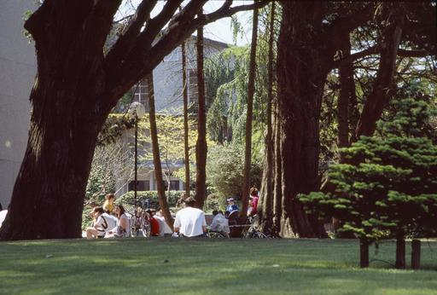

1. **DIRECTIONS TO THE MAIN CAMPUS [See Campus Map – 14]**

The main campus of UCC is half a mile west of Cork city centre, about 15 minutes’ walk along Washington Street. The College Gates on Western Road are ceremonial (foot access only): the entrance to the main campus is on College Road, and there are side entrances on Donovan’s Road, Gaol Walk and other entrances on College Road. Other UCC locations around the city tend to have a single main entrance.

There are usually plenty of taxis in the city and at the airport, rail and bus stations, but check the location of the interview and make sure you give the driver the correct address. Taxis from the city centre cost about €8. ABC Taxis (021) 4961961 and Cork Taxi Co-op (021) 4272222 are two taxi firms that operate throughout the city and surrounds.

**By Car**

From the city centre, follow the signs to Killarney and West Cork: Go west out of the city along Washington Street; go through the first two traffic lights. Pass the River Lee Hotel on your left. Turn left at the third traffic lights by the old College gates (if you are walking you can enter the campus here or through the next gates up Donovan’s Hill). Go up Donovan’s Road, past the Honan Chapel on your right; At the top of the hill, turn right onto College Road; For the main entrance to the College go 200m further down College Road, on your right.

**Parking – See Maps, Section 14**

Parking on the main campus is EXTREMELY restricted and is limited to permit holders, deliveries, those on official business and cars with disabled stickers. Other UCC

locations have very limited visitor parking particularly during term time. Some visitor parking may be found in Perrott’s Inch and Perrott Avenue car parks on an hourly charge (see separate map provided).

Perrott’s Inch car park is located on Gaol Walk and may be reached by passing the main UCC entrance on Western Road and turning left at the next traffic lights. The car park is located on the left hand side before the bridge.

To get to the Perrott Avenue car park, drive to the top of Donovan’s Road and turn right into College Road. Perrott Avenue car park will be immediately on your left. If you are driving to UCC for interview, please allow yourself plenty of time to find parking.

**By City Bus**

UCC is served by two City Bus routes (No.205 and No.208) connecting the campus to Cork City Centre via Washington and St Patrick Streets. Bus stops are located on College Road/ O’Donovan’s Road (Route No.205—about four buses each hour) and Western Road (Route No. 208—about every 15 minutes). Route No 210 buses serve Bandon Road at close walking distance to the Main Campus.

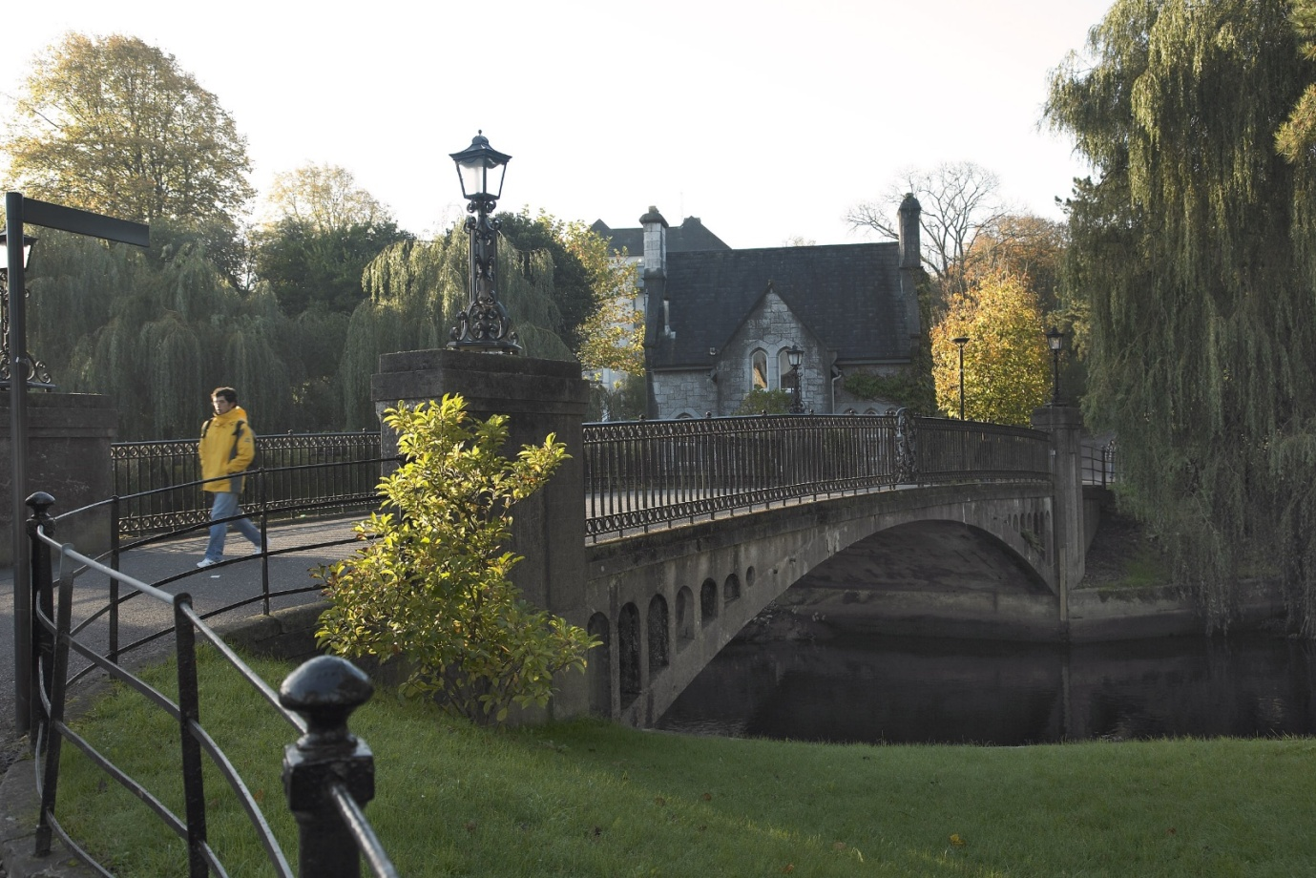

**By Train**

From Dublin (Heuston), about 8 trains a day, journey time about 3 hours. See Iarnrod Éireann’s timetables. Trains stop at Mallow for connections with Killarney, and at Limerick

Junction for connections with Limerick (for Shannon Airport). Taxis from the rail station cost about €15 and there is also a city bus meeting some trains.

**Iarnrod Éireann**

Rail Passenger Enquiries 021 4557277

[**www.irishrail.ie**](http://www.irishrail.ie)

**By long-distance bus**

From Dublin (Busaras), about 6 buses a day, journey time about 5 hours. (See Bus Éireann’s timetables.)

Taxis from the bus station cost about €12 and most city buses also stop at the bus station, which is about 300m from Patrick Street in the city centre. There is an overnight coach to and from London (Victoria Bus Station) which travels via the ferry service between Rosslare (Co Waterford) and Fishguard or Milford Haven (Wales).

**Bus Éireann** 021 4508188

Bus Station Parnell Place, Cork.

[**www.buseireann.ie**](http://www.buseireann.ie)

**By air**

Cork Airport has frequent flights to Dublin and London with Aer Lingus (Heathrow and Gatwick) and RyanAir (Stanstead and Gatwick) and to a wide range of other UK and European destinations. See AerRianta’s web site pages for details of movements. Taxis from the airport cost about €18 and there is also an airport bus every hour during the day. All the major car rental companies have desks at the airports.

Travellers coming via Europe change at Dublin, or London where there is no direct flight to Cork. Travellers coming via North America change at Dublin, or Shannon (there are no flights between Cork and Shannon as it is so close; see the rail and bus timetables).

**Cork Airport**

[**www.corkairport.com**](http://www.corkairport.com) 021 4313131

**Entry Visas**

People from certain countries need a valid Irish entry visa before they can land in the country. You do not need a visa to land in Ireland if you are a citizen of one of the countries listed on the following [link](http://www.foreignaffairs.gov.ie/home/index.aspx?id=8777) [**http://www.foreignaffairs.gov.ie/home/index.aspx?id=8605**](http://www.foreignaffairs.gov.ie/home/index.aspx?id=8605)

If you are not from one of the countries listed above you will require an entry visa. To apply, contact the Irish embassy or consulate in the country where you live. It may also be possible to apply online if you live in a country where the online facility is available. Please see [HERE](http://www.inis.gov.ie/en/INIS/Pages/WP07000015) for more information on applying for a visa.

Please note: The standard non-refundable visa application processing fee is €60 for a single-journey visa. This will be valid for one entry into the State within 90 days of issue. If you then wish to leave the State (this includes travel to Northern Ireland) you will then need a re-entry or multiple-entry visa to re-enter the State.

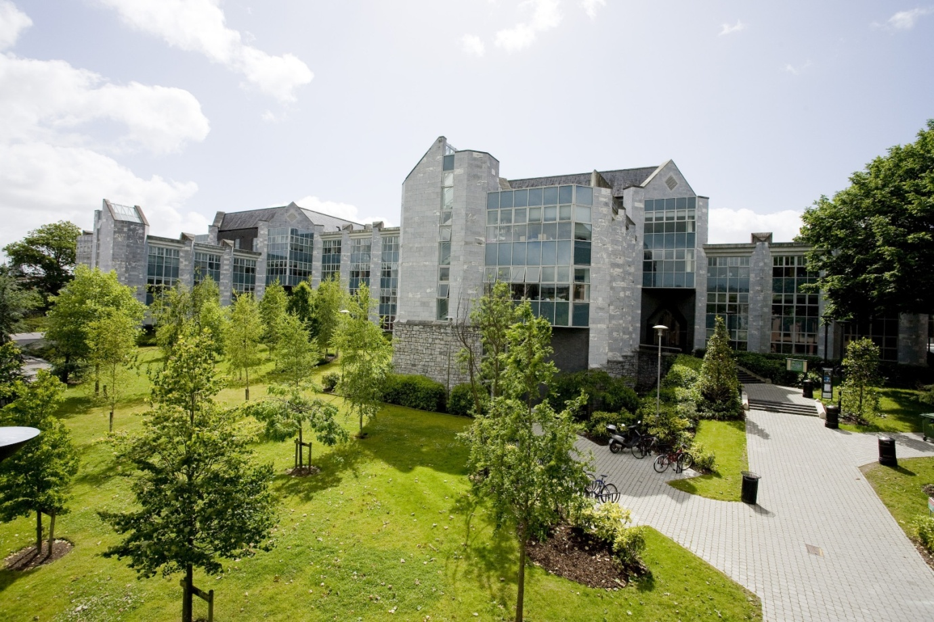

*The O’Rahilly Building, Business and Humanities*

1. **EXPENSES FOR CANDIDATES ATTENDING FOR INTERVIEW**

Candidates travelling from outside Cork are entitled expenses for travelling to Cork, on production of original and complete receipts in accordance with the following allowance limits.

Other than in exceptional situations as agreed by the University, the maximum allowances available to candidates are as follows

Candidates travelling from within the island of Ireland €125

Candidates travelling from mainland Europe and the UK €500

Candidates travelling from USA or any other location €1,000

Candidates should always choose the most economical means of travel. Public transport should be used where feasible and public transport costs at the standard class train rate will be re-imbursed, irrespective of car usage where such direct public transport exists.

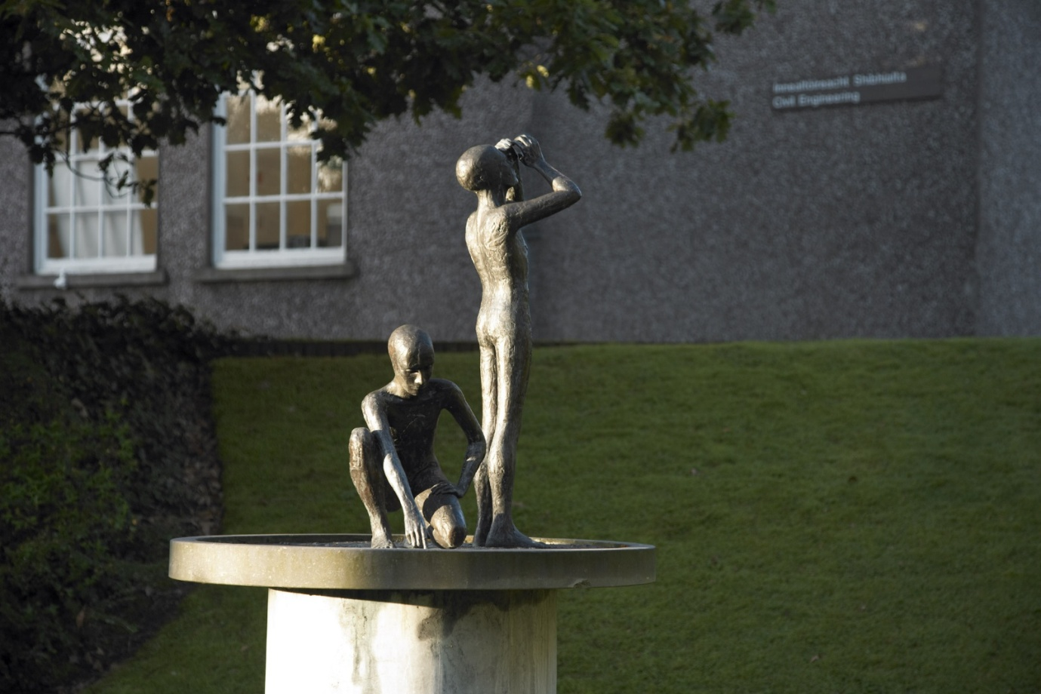

*A Tradition of Independent Thinking*

**Accommodation**

Costs of accommodation should be borne out of the allowance available as detailed. There are a number of suitable guesthouses in the vicinity of the University as follows:

Garnish House, Western Road (Tel +353 21 427 5111)

Crawford House, Western Road (Tel +353 21 427 9000)

Prices: Approximately €60 for a single room.

Further accommodation listings can be provided by the Recruitment Office. Candidates requiring assistance in booking accommodation should contact the Department of Human Resources, Recruitment Office on 021 490 3603 or e-mail: [**recruitment@per.ucc.ie**](mailto:recruitment@per.ucc.ie)

**Administration**

An expenses form (<http://www.ucc.ie/en/hr/policies/forms/misc/Candidate-Expenses-Form.xls>) should be completed and receipts must be submitted in respect of costs claimed and should be securely attached.

Please forward the completed expenses form to the Recruitment Office for approval following interview.

Payment will be made directly into a candidate’s bank account on completion of the required bank details on the expenses form.

Expenses Claims, once submitted, will normally take a minimum of six weeks to process.

Should you have any queries concerning this expenses policy or require any further assistance or additional information, please contact the Department of Human Resources, Recruitment Office on 021 490 3603 or e-mail: [recruitment@per.ucc.ie](mailto:recruitment@per.ucc.ie)

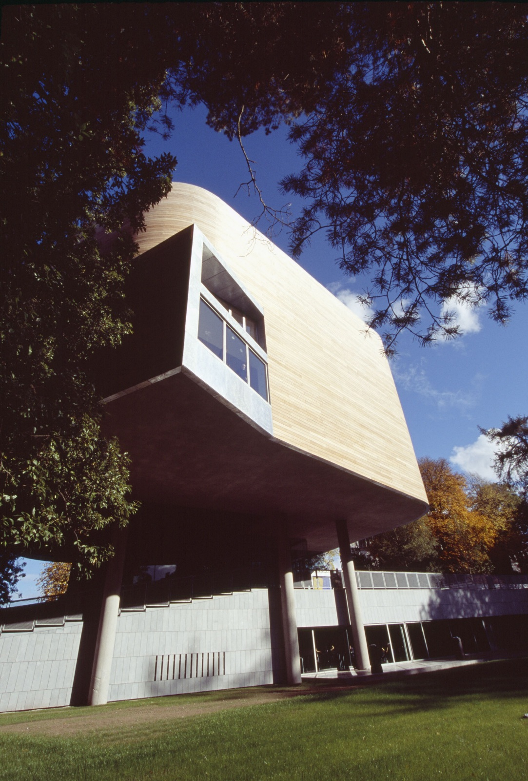

*The Glucksman Gallery*

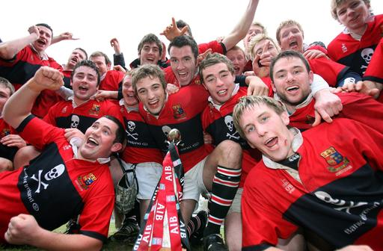

*A proud sporting tradition*

1. **CAMPUS MAPS**

**Download**:

**Main Campus Map at**: [**http://www.ucc.ie/en/media/UCC_campus_map_Edition1_2010new.pdf**](http://www.ucc.ie/en/media/UCC_campus_map_Edition1_2010new.pdf)

**Visitor Parking Map at**: [**http://www.ucc.ie/en/media/visitor-parking.pdf**](http://www.ucc.ie/en/media/visitor-parking.pdf)

**Places to Eat on Campus**: [**http://www.ucc.ie/en/media/places-to-eat.pdf**](http://www.ucc.ie/en/media/places-to-eat.pdf)

1. See also: http://www.ucc.ie/en/about/UCCHistory/
2. For alumni of UCC see: http://www.ucc.ie/en/alumni/who/