CANDIDATE INFORMATION

**COMMERCIALISATION CASE MANAGER**

**(4 POSTS)**

Office of Technology Transfer

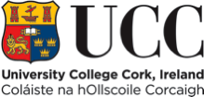

**CONTENTS**

**Information for Candidates**

1. Welcome from the President

1. About Cork

1. University College Cork
2. University Strategic Plan
3. University Organisational Structure

1. Information on the School / Department
2. Job Description
3. Equality of Opportunity Statement
4. Housing, Education, Medical Insurance & Tax Information
5. Useful Web Links

**Additional Information for Shortlisted Candidates**

1. Interview Format
2. Directions to UCC
3. Expenses for Candidates Attending for Interview
4. Campus Maps

1. **WELCOME FROM THE PRESIDENT**

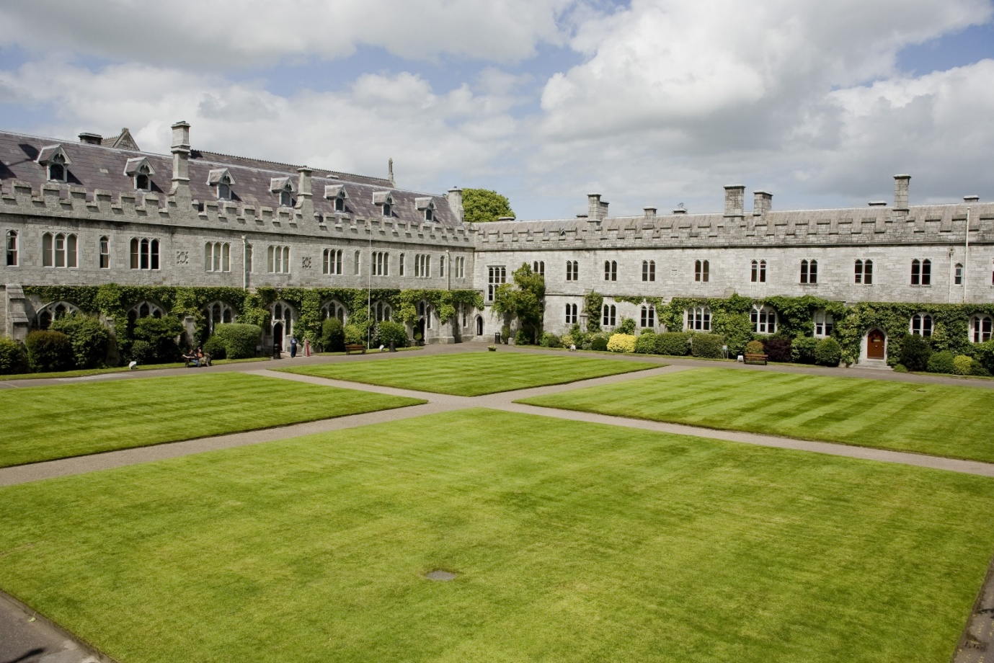

Now that you are considering a career at University College Cork (UCC), let me thank you for your interest and introduce you to our University.

Originally founded in 1845 as "Queen's College Cork", UCC is one of Ireland's oldest institutions of higher education. Ranked in the top 2% of universities worldwide, UCC was named as Ireland’s *Sunday Times* University of the Year in 2011, the third time in 10 years to receive this designation. In 2011, UCC became Ireland’s first Five Star University (under the QS ranking system) and was named the World’s First Green University Campus (Federation for Environmental Education, Copenhagen).

UCC boasts a spectacular campus in a compact university situated in a global tourist destination. The University serves a community that is both local and global. We are a comprehensive, multi-disciplinary university. During our 160 year history, staff or students here have invented the logic on which computer programming is based (George Boole, Professor of Mathematics 1849-54), discovered the cause of the tropical disease, leishmaniasis (Charles Donovan, medical student during the 1880’s) invented the world’s first junction-less transistor (Professor Jean-Pierre Collange, 2010) became Supreme Court Judge (Liam McKechnie, 2010) and much more. We have nurtured composers, poets and playwrights. We have taught over 100,000 alumni who lead and serve society throughout the world.

Today, UCC’s student body of some 20,000 includes over 2,800 from 100 countries across all continents. We employ 2,700 professionals. Over one third of our academic staff have come from overseas. We enjoy many accolades as a high quality employer. The true strength of our university lies in the people who work and study here. The diversity of our workforce and our students is our competitive edge in realising our mission to “*create, preserve, and communicate knowledge and to enhance intellectual, cultural, social and economic life locally, regionally and globally*.”

Our vision - UCC a contemporary Irish University with a global outlook will, I trust, prove attractive to you. This briefing pack contains information which I hope will be useful and informative should you be selected to attend for interview here in Cork.

I trust that your experience of our recruitment process will be a positive one and I thank you, again, for considering a career at University College Cork.

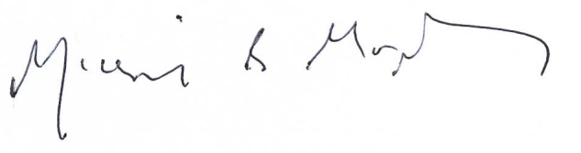

[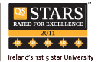](http://www.topuniversities.com/qsstars/ireland)

Dr Michael Murphy

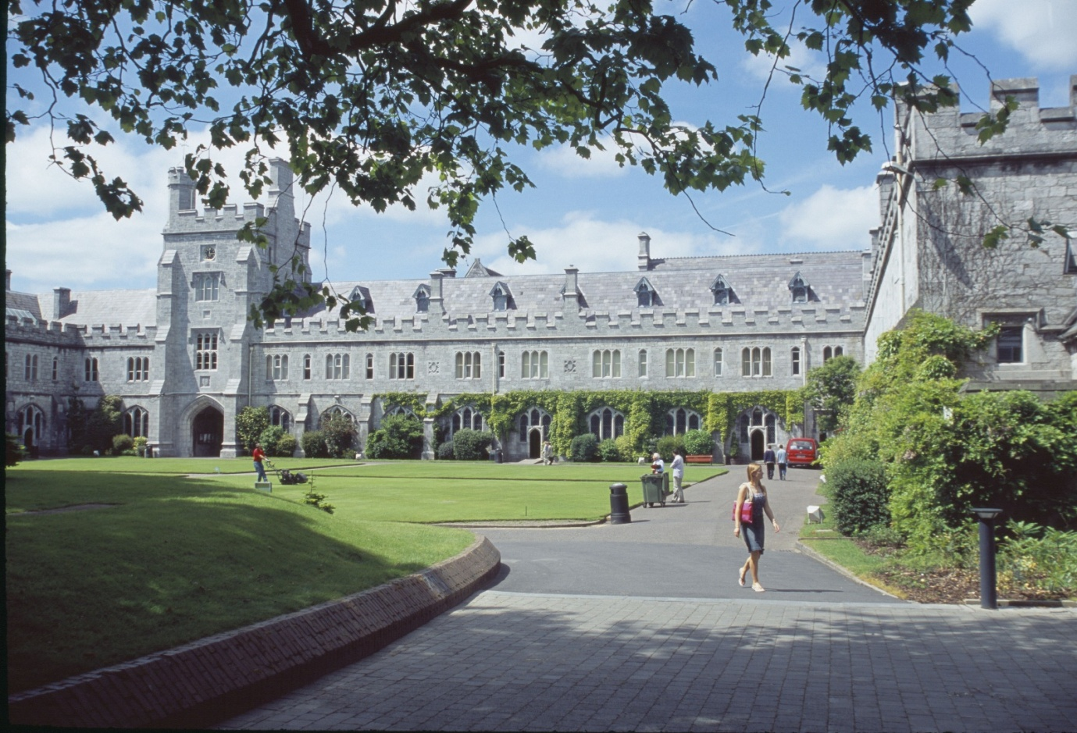

1. **ABOUT CORK**

Recently identified as one of the top ten destinations to visit by the Lonely Planet guide, Cork is a place not just to visit, but to live; offering a quality of life and an academic and cultural experience which reflects positive Irish values. Cork city has a population of some 150,000, with a further 100,000 in the city’s hinterland. Further details can be found at [**http://www.corkcity.ie/**](http://www.corkcity.ie/)

1. **UNIVERSITY COLLEGE CORK [UCC][1][2]**

UCC was established in 1845 as one of three Queen’s Colleges at Cork, Galway and Belfast.  The site chosen for the college is particularly appropriate given its connection with the patron saint of Cork, St Finbarr.  It is believed his monastery and school stood on the bank of the river Lee, which runs through the lower grounds of the University.  The University’s motto is ‘Where Finbarr Taught, let Munster Learn.’ University College Cork (UCC) is the principal university in the province of Munster and the largest outside Dublin

UCC, which has a current enrolment of close to 20,000 students, provides over 120 degree and professional programmes through some 60 Disciplines and offers a research-led curriculum that attracts the highest calibre of students. UCC attracts a large number of international students currently in excess of 2,800.

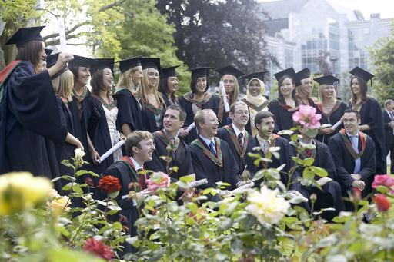

The University offers an innovative, research-led curriculum, taught by world-class academics that consistently attracts a quality student intake. UCC has established four Colleges to enhance the University’s research and teaching efforts:

* + Arts, Celtic Studies and Social Sciences
  + Business and Law
  + Medicine and Health
  + Science, Engineering and Food Science

Colleges are managed by Heads of College and supported by College Managers, Financial Analysts, HR Managers as well as dedicated administrative support. College-level committees are aligned to Academic Council Committees to enhance decision making, policy implementation and information flow.

UCC employs some 2,700 staff. UCC is committed to building its capacity to carry out research of the highest international quality, and to providing research-lead teaching across the breadth of disciplines and specialisms typical of a traditional university. UCC also prides itself on close connections with the professions, industry and the local community. Further information on UCC including information on Academic and Administrative Departments can be found on the UCC web site. The UCC home page address is www.ucc.ie.

The University budget is in the order of €280m. The University is directly funded by the Higher Education Authority (HEA), receives grant, fees and other income, and also generates levels of research income which for many years have been the highest in the State (in 2010-11 €80m). The University budgetary strategy continues to focus on decreasing its reliance on Exchequer income and promoting income generation through increasing post graduate and international fee income.

UCC consistently delivers a globally significant contribution in research and in teaching and learning, which has secured the University a place in the top 2% of Universities worldwide in the QS World University Rankings (2010). UCC is committed to building its capacity to carry out research of the highest international quality and to providing research-led teaching across the breadth of disciplines and specialisms typical of a traditional university. UCC was the first Irish university to conduct an institution-wide research quality review in 2009.

The University has benefited very substantially over the past ten years from national programmes aimed at developing research infrastructure, capacity and output, mainly funded through the National Development Plan and in line with the Government’s Strategy for Science, Technology and Innovation. It has in this way developed its key role in plans for the long-term economic and social development of the region and the country, the city of Cork being a primary gateway in Ireland’s Spatial Strategy. These developments have also been substantially supported through private funding raised by the University.

The University contains a number of highly prestigious research centres including the Alimentary Pharmabiotics Centre – [**www.ucc.ie/research/apc**](http://www.ucc.ie/research/apc) and the Tyndall National Institute. See [**http://www.tyndall.ie/**](http://www.tyndall.ie/). Indeed in early 2013, the University has been extremely successful in a recent SFI Research Centre programme, the largest joint state/industry research investment (€300m) in Irish history: UCC is to lead four of the seven centres, co-lead a fifth and is partner in the remaining two centres.

<http://www.ucc.ie/en/news/newsarchive/fullstory-215713-en.html>

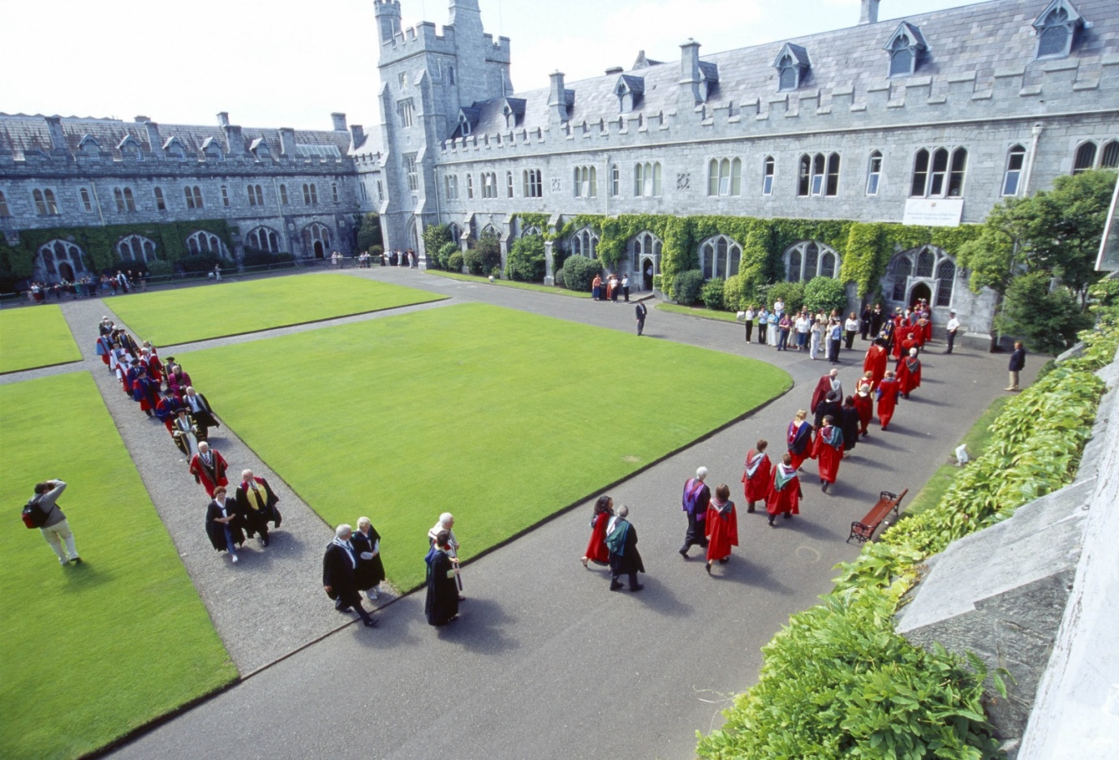

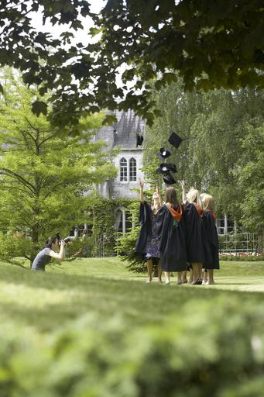

The functions of the University are performed under the direction of the Governing Body. The Academic Council, subject to the financial constraints determined by the Governing Body and to review by it, controls the academic affairs of the University. The main executive management group is the University Management Team, which works in support of the President.

University College Cork (UCC) was selected as Ireland’s University of the Year 2011/12 by *The Sunday Times.* This award was given for a number of reasons including recognition of the University’s position as the leading research institution in Ireland; the University’s cosmopolitan character which encompasses an admirable student mix; the excellence of UCC’s teaching and academic standards and the University’s links with business and industry.

The *Sunday Times* award, which was the third occasion UCC received the award, followed on the heels of UCC becoming the only Irish university to achieve the unique status of Ireland’s first five star university.

UCC is also the first university campus to be awarded the Green Flag for an environmentally friendly campus in a student-led innovation. UCC is proud of its achievement as the world’s first university to achieve the ISO 50001 standard in energy management systems

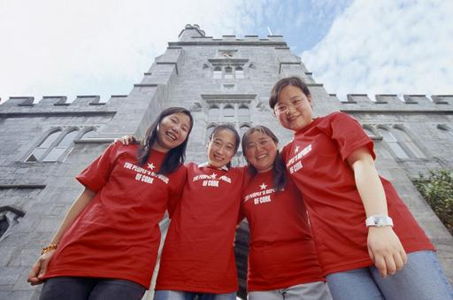

**Tours of the University & School/Departmental Visits**

A virtual tour of UCC is available on [**http://www.ucc.ie/en/visitors/see-do/**](http://www.ucc.ie/en/visitors/see-do/)

For some positions, you will also be offered an opportunity to tour the relevant department/school.

1. **UNIVERSITY STRATEGIC PLAN**

Details of the UCC Strategic Plan can be found on [**http://www.ucc.ie/en/strategicplanning/strategic/**](http://www.ucc.ie/en/strategicplanning/strategic/)

1. **UNIVERSITY ORGANISATIONAL STRUCTURE**

Governing Body

President

Academic Council

Arts Celtic

Studies &

Social Sciences

Science

Engineering &

Food Science

Medicine

&

Health

Business

&

Law

Registrar

Senior VP

Academic

Bursar

&

CFO

Academic Secretary

VP

Research &

Innovation

VP

Teaching &

Learning

Head

Student

Experience

-School of Applied Psychology

-School of Applied Social Studies

-School of Asian Studies

-School of Education

-School of English

-School of History

-School of Geography & Archaeology, Human Environment

-School of Irish Learning

-School of Languages, Literature & Cultures

-School of Music & Theatre

-School of Sociology & Philosophy

-School of Asian Studies

-Classics

-Study of Religion

-Computer Science

School of Mathematical Science

-Biological, Earth & Environmental Sciences (BEES)

-Engineering

-Food Science

-Chemistry

-Physics

-Biochemistry

-Microbiology

-School of Medicine

-School of Dentistry

-School of Nursing & Midwifery

-School of Clinical Therapies

-School of Pharmacy

-Accounting Finance

And Information Systems

-Economics

-Food Business & Development

(Centre for Cooperative Studies)

-Government

-Management & Marketing

-Centre for Policy Studies

-Law

Director

Quality

Promotion

Corporate

Secretary

&

Dir. HR

Director

Inf Services

& Librarian

Director

Estates &

Infrastructure

Director

Planning &

Inst Research

VP External

Relations &

Development

**COLLEGES**

1. **INFORMATION ON THE OFFICE OF TECHNOLOGY TRANSFER**

University College Cork established the Office of Technology Transfer (OTT) in 2007 replacing the Industrial Liaison Office. Supported by Enterprise Ireland, the office has an expanded remit and team. The OTT aims to support the university in all aspects of technology transfer, industrial interaction and innovation services.

The OTT as part of the Office of the Office of Vice-President for Research and Innovation operates with the university’s strategic plan for research (available at <http://www.ucc.ie/research/rio/documents/ResearchandInnovationStrategicPlanbodyFINAL.pdf> )

The Office of Technology Transfer incorporates

* technology commercialization,
* start-up company incubation facilities and
* Graduate enterprise training and support activities.

The Office has a current allocation of 12 staff covering these functions. This is complemented by support for other offices in UCC such as Research Support Services, Corporate and Legal Affairs and Research Grants and Contracts. Collectively we aim to drive the commercialization of research and technology transfer through mechanisms such as licensing patents, creating spin-out companies, supporting external start-up companies and engaging proactively with business and industry to stimulate economic, social, and cultural development. Since its establishment the UCC TTO has executed over 70 licenses and established 12 campus companies. Research income from our industrial research engagement has increased from 2% to 6% of the annual research budget reflecting the increased importance of this sector to our university. This does not include the research income provided by the state leveraged from this industrial income such as Innovation Partnership programs from Enterprise Ireland, Research Centre funding from Science Foundation Ireland and student scholarships from the Irish Research Council.

In 2013 UCC, supported by Enterprise Ireland, led the establishment of a consortium for Technology Transfer bringing together UCC, Cork Institute of Technology and Teagasc, the national Agricultural and Food Development Authority. Building on existing strategic relationships and research collaborations that underpin institutional excellence, our partnership aligns the technology transfer activities of each organisation to enhance delivery of impact from national investment in research. This will be a key development and strategic influence on the Office over the next 4 years with staff of the office supporting the commercialization efforts of our partners under the auspices of this consortium.

Technologies are commercialized through a team of commercialisation specialists and commercialisation case managers dedicated to a range of technology areas. The major demand for our services has traditionally come from Life Sciences, ICT and Physical sciences. This demand is now expanding across the university as innovation, commercial engagement and technology commercialization become embedded within the university research community. The case managers are available to all research teams within UCC including all the research centres such as Tyndall National Institute and the Alimentary Pharmabiotic Centre, the Enterprise Ireland funded technology centres and will serve the newly established research centers funded in the most recent round of SFI Research Centre awards to UCC.

1. **JOB DESCRIPTION**

University College Cork (UCC) is internationally acclaimed as one of Ireland’s leading research institutions with research income standing in excess of €80M per year. UCC’s research strength and its commitment to industry engagement is highlighted by the recent establishment of SFI Research Centres <http://www.ucc.ie/en/researchcareers/news/newsbody-242003-en.html> . As the rate of idea generation grows, the University is consolidating its focus on intellectual property protection, commercialisation and technology transfer capability through the Office of Technology Transfer. The Office of Technology Transfer (OTT) is charged with encouraging and supporting the commercialisation of knowledge from all parts of the university. With the support of Enterprise Ireland, the UCC Office of Technology Transfer is leading a Technology Transfer consortium with Cork Institute of Technology and Teagasc, Agriculture and Food Development Authority.

The core services to be provided to researchers by Commercialisation Case Managers within this consortium include the identification, protection and commercialisation of Intellectual Property (IP) from the research activity of the institutions involved. They will also be expected to support and facilitate research engagement with industry. In order to successfully and efficiently drive this effort, the relationship with the academic community, industry, the development agencies, commercial funding sources, etc. is a critical focus.

The Commercialisation Case Managers will support the growing IP portfolio at UCC, CIT and in Teagasc and will drive commercialisation of their research output. The University is seeking to appoint four Commercialisation Case Managers for a three year period. One Commercialisation Case Manager will work closely with Teagasc and will be based at Teagasc’s Technology Transfer Office at Oakpark, Co. Carlow.

**Principal Duties & Key Responsibilities**:

The Technology Transfer Commercialisation Case Managers will report to the Director of Technology Transfer, within the Office of the Vice President for Research & Innovation, and will be expected to:

* Engage with and support Principal Investigators and research teams and centres in the consortium institutions in the identification, protection and market evaluation of intellectual property;
* Develop, support and execute commercialisation strategies for exploitation of IP including technology marketing, valuation, licence negotiation with support from the UCC Commercialisation Specialist;
* Support the relevant technology transfer office and the research community in the establishment of spin-out companies;
* Facilitate contact and negotiations between research groups and third parties who are relevant to the commercialisation of their research. This will include public and private sector enterprise support entities, potential research and technology development partners, technology licensees and relevant technology commercial contractors;
* Stimulate access by researchers to the range of support programmes and services provided by UCC and other agencies such as Enterprise Ireland to assist with technology transfer initiatives;
* Promote awareness of IP and technology transfer issues within the research community and work closely with the consortium’s collaborative base in industry;
* Support the existing technology transfer activities in our partner institutions in consultation with their research commercialisation officers to deliver the services described above

Operating as a staff member of the Technology Transfer team, the successful candidate will contribute to the overall effectiveness of the team’s effort to commercialise research including by:

* Developing contacts and linkages within the appropriate University and National structures;
* Contributing to the development and implementation of University policies and processes for the commercialisation of research.

The appointees will be requested to sign a confidentiality clause and observe a confidentiality agreement.

**Note:**  *As the university continues to expand and evolve, and in the light of evolving university legislation, it is likely that flexibility in regard to the allocation of specific duties will be necessary.  Accordingly, the list of duties specified above is not intended to be exclusive or restrictive; duties may be added or withdrawn but any such alteration will take place after consultation with the appointee.*

#### Person Specification/Selection Criteria

Decisions at shortlisting and interview will be made based on the following criteria-:

**Essential**

* Enthusiasm and drive to deliver on commercialisation of research
* Team player with strong interpersonal, communication and negotiation skills.
* Demonstrated capability to combine team skills with personal initiative and demonstrated ability to operate in a team based management structure.
* Demonstrated capability to establish strong working relationships and credibility within research teams and with industry clients.
* Flexibility in terms of work practices with the ability to prioritise and manage an extensive agenda.
* Demonstrated ability to develop effective networks, build and manage relationships on all levels.
* Demonstrated ability to plan effectively, meet deadlines and work productively under pressure is essential.
* Demonstration of the Knowledge, Skills and Experience relevant to the post.

## Knowledge, Skills and Experience Required

The Technology Transfer Commercialisation Case Manager post holders will have the experience, energy, credibility, enthusiasm and commitment to make a success of a challenging and rewarding role.

Suitable candidates should have:

**Essential**

* A research -based post graduate degree in Science or Engineering.
* Excellent communication and organisational skills.
* Demonstrated ability to work well both independently and as part of a team.
* Excellent management capability and track record is required.
* Experience in IP management and commercialisation of research in an academic or industry setting.
* An ability to assimilate and understand scientific and technological issues and to assess their commercial potential.

**Desirable**

* Relevant experience in the identification and commercialisation of intellectual property through licensing or new enterprise development.
* Knowledge of business development and licensing issues in a research intensive environment would also be highly desirable.
* Direct industry experience in R&D, Product Management or Sales and Marketing or business development in a relevant sector *or* extensive experience in working at the academic – industry interface would be an advantage.

*Candidates are requested to make a personal assessment of these criteria against their own qualifications, skills and abilities to assess whether they should apply for the post.*

**Conditions of Employment:**

**Salary** within the scale: Admin I (€65,000 - €83,078). ***The scale quoted is subject to change. In all instances the successful appointment will be at the first point of the scale***

**Normal hours of duty** are Monday to Thursday inclusive 9.00 a.m. to 5.30 p.m. and 9.00 a.m. to 5.00 p.m. on Friday, with 60 minutes for lunch daily. Due to the nature and seniority of the post, however, it may be necessary to extend and vary these hours from time to time in order to meet the exigencies of the post.

**Annual leave** is 26 working days per annum with additional leave at prescribed times, total 34 days per annum.

**Sick Leave**: Subject to certain conditions staff may be allowed up to 130 working days sick leave at full pay and a further 130 working days, at half pay in any 12-month period. This is subject to the staff member not exceeding 260 working days, (1 year) sick leave, at either full or half pay, in any period of 4 years.

The **tenure** of the post is a 3 year post. It is based on the following provisions:

(a) A probationary period of twelve months shall apply from commencement of employment in the post during which the contract of employment may be terminated by either party in accordance with the Minimum Notice and Terms of Employment Acts, 1973 to 2001. The probationary period may be extended at the discretion of the University.

(b) Except in circumstances of gross misconduct justifying immediate dismissal, the appointee will receive one month's notice of termination of employment, or, if greater, such notice as is provided for in a minimum notice in terms of Employment Act, 1973.

(c) The appointee is required to give one month's notice of termination of employment.

(d) Under the Public Service Superannuation Act 2004, for all new entrants to the Public Sector on or after April 2004, the normal retirement age is 65. It is no longer possible therefore to retire before age 65.

**Pension:** The appointee will become a member of the Single Public Service Pension scheme, which provides personal retirement benefits as well as benefits for spouses and children.The contribution rate comprises 3% of pensionable remuneration and 3½% of net pensionable remuneration. Tax relief is accrued on these payments.

In addition, additional dependants’ benefits can be provided by membership of the **Voluntary Life Assurance Scheme.**

Membership of the **Income Continuance Plan** is mandatory (for contracts that exceed two years). This provides additional payment where salary is reduced or ceased because of long-term illness or injury. Contributions, which are tax-allowable currently, amount to 0.80% (gross) of salary.

Membership of the **Group Personal Accident Scheme** shall apply to all employees, subject to individual acceptance by the Insurance Company. The salary quoted is subject to a deduction from salary at the rate of .06%

The **Pay Related Social Insurance Class** A1 rate of Pay Related Social Insurance (PRSI) applies to the post.

**Voluntary Health Insurance**: A VHI/Laya/ Aviva Health/ HSA/GloHealth group scheme is in operation and contribution may be deducted from salary, with effect from the Scheme’s renewal date (May of each year).

**Additional benefits**: We offer progressive employment and training policies including opportunities for further studies. Staff can avail of membership of a variety of clubs and societies and a wide range of facilities on campus, including a leisure centre.

**Certificates and Testimonials:** These documents should not be sent with the application. Candidates who are selected for interview will be requested to submit the necessary documentation.

Shortlisted candidates for posts shall be required to appear in person before a Board of Assessors in Cork, in which case travelling and subsistence expenses at approved rates will be paid.

A successful candidate will be required to submit a birth certificate, documentary evidence confirming academic qualifications.

References will be sought in relation to all candidates invited to attend for interview.

Please note that if you are considering applying for this post you must be able to supply proof of the right to work in Ireland.  If you do not have the right to work in Ireland you would need to obtain a **work permit**.   We are obliged by European law to appoint people who are citizens of the European Economic Area (EEA) where possible.  Where there is no skills shortage for a particular post, it is highly unlikely that a work permit would be granted.

Candidates may be required to produce documentary evidence to support any statements made by them on their application form or any supporting documentation.  Candidates should note that the submission of any inaccurate information will invalidate their application.

*Note: Candidates should note that any inaccurate information will invalidate their application.*

For informal enquiries about the post, please contact Dr. Timothy Roche, Director of Technology Transfer, Tel: 021 4205881 email: [troche@ucc.ie](mailto:troche@ucc.ie). For more information on the Technology Transfer Office please visit <http://techtransfer.ucc.ie/>

Each candidate must complete an application form for the post (available at <http://www.ucc.ie/en/hr/policies/forms/application/> ). The completed application form must be returned ***by email*** to [recruitment@ucc.ie](mailto:recruitment@ucc.ie).

For any queries regarding the application process please contact the Department of Human Resources, Block E, Food Sciences Building, University College Cork. Tel: +353-21-4903603.

Closing date for Receipt of Applications:  **Thursday, 31st October 2013 at 5.00pm**

**UNIVERSITY COLLEGE CORK IS AN EQUAL OPPORTUNITIES EMPLOYER**

**Please note that an appointment to posts advertised will be dependent upon University approval, together with the terms of the employment control framework for the higher education sector**

1. **EQUALITY OF OPPORTUNITY STATEMENT**

University College Cork is an equal opportunities employer actively working towards full equality of opportunity in all aspects of University life.

1. **HOUSING, EDUCATION, MEDICAL INSURANCE AND TAX INFORMATION**

**Housing**

**Renting in Cork**

Houses - family homes €750 to €1,400 per month depending upon quality and location.

Apartments - €600 to €1,200 per month. The best source of information for people seeking to rent accommodation are Letting Agents, Auctioneers, National and Local Press.

A selection of Cork Auctioneers is listed below:

O’Mahony Walsh & Associates Tel: 021 4278606

James G. Coughlan & Assoc. Tel: 021 4251500

Sherry Fitzgerald Tel: 021 4273041

**Buying and Renting Property in Cork**

Information on renting and buying a property in Cork can be found on the following websites:

Staff accommodation pages on the UCC Accommodation and Student Activities webpages

[**www.ucc.ie/services/asa/**](http://www.ucc.ie/services/asa/)

Comprehensive Irish Property websites for sales and lettings

[**www.daft.ie/**](http://www.daft.ie/)

Cork based auctioneers, estates agents and property management company

[**www.choices.ie**](http://www.choices.ie)

Residential lettings and sales

[**www.sherryfitz.ie**](http://www.sherryfitz.ie)

Irish Auctioneers & Valuers Institute (IAVI) - Site containing a comprehensive listing of property and real estate from a selection of IAVI members.

[**www.ipav.ie**](http://www.ipav.ie)

Irish property News - Online publication providing property listings and information relating to buying a property in Ireland.

[**www.irishpropertynews.com**](http://www.irishpropertynews.com)

Property website and home portal providing property, services, home and garden products and online mortgages.

[**www.myhome.ie**](http://www.myhome.ie)

**Education– Schools in Cork**

There are several excellent schools in Cork City, located near the University, primary and post primary. The Department of Education, Communications Section, Dublin will provide further information on any queries in this connection Tel +353 1 8896400. The Department of Education also have an Inspectors Office in Cork +353 21 4906011



**Medical Insurance**

There is no state run statutory medical insurance scheme in Ireland. Hospital medical treatment is generally speaking, free while visits to general practitioners cost around €60 each and all prescription medicines must be paid for. However many people choose to avail of private medical insurance to cover the cost of upgraded hospital treatment and to avoid sometimes lengthy waiting lists. There are three established medical insurance companies active in Ireland at present as follows:-

**VHI -** [**www.vhi.ie**](http://www.vhi.ie)

**Laya Healthcare -** [**www.layahealthcare.ie**](http://www.layahealthcare.ie)

**Aviva Health Insurance -** [**www.avivahealth.ie**](http://www.avivahealth.ie)

These companies offer tailor made health care plans which can be selected by employees according to their requirements. Subscriptions can be deducted from salary payments. Competitive rates are available to UCC staff. Further information is available on these providers via the Department of Human Resources.

The differences in cover between the various plans are highly complex. Contacting each company to assess which plan may be most suitable for your individual needs is best.

**Personal Taxation**

Income tax is deducted from employees’ wages by their employers under a Pay as You Earn (PAYE) scheme and is calculated according to the annual salary received. For further and complete information concerning your own personal taxation situation, you are advised to contact the Revenue Commissioners directly. Information for those new to the Irish personal taxation system is available on the Irish Revenue website [**www.revenue.ie**](http://www.revenue.ie)

1. **USEFUL WEB LINKS**

You Tube [**www.youtube.com/uccireland**](http://www.youtube.com/uccireland)

Facebook [**www.facebook.com/universitycollegecork**](http://www.facebook.com/universitycollegecork)

UCC Virtual Tour [**www.ucc.ie/virtualtour**](http://www.ucc.ie/virtualtour)

UCC Strategic Plan [*http://www.ucc.ie/en/strategicplanning/strategic/*](http://www.ucc.ie/en/strategicplanning/strategic/)

[**www.movetoireland.com**](http://www.movetoireland.com)

Comprehensive website providing specific information for those relocating to Ireland from abroad.

[**www.cork-guide.ie**](http://www.cork-guide.ie)

For general information on accommodation, restaurants, shopping, transport and weather in Cork.

[**www.citizensinformation.ie**](http://www.citizensinformation.ie)

Information on living and working in Ireland and information on public services. This website is a gateway to many Irish services.

[**www.emigrant.ie**](http://www.emigrant.ie)

Basic Information on Living and Working in Ireland including information on income tax and Pay Related Social Insurance (PRSI), housing, health services, citizenship and naturalization, the cost of living and education.

[**www.corkcity.ie**](http://www.corkcity.ie)

General interest site from Cork City Council providing information on Cork City.

[**www.cso.ie**](http://www.cso.ie)

Statistical information from the Government body responsible for compiling Irish official statistics on the economy, employment, trade, industry, population and the national accounts.

**INFORMATION FOR CANDIDATES CALLED TO INTERVIEW**

1. **INTERVIEW FORMAT**

**Academic Appointments**

Candidates for Academic posts are ordinarily interviewed by a Selection Board consisting of a number of internal staff members of the University and at least one external member.

Interviews for Academic posts are of approximately forty-five minutes’ duration depending on the seniority of the position.

Candidates can expect to be questioned on their teaching experience, research record and academic administration and contributions to date. They would also most likely be asked to outline their interest in the particular post and their future plans in the area.

It should be noted that candidates will also be expected to give a presentation prior to the interview (probably on the preceding day). Such presentations are organised by Human Resources together with the relevant school/department and information relating to these will be forthcoming from a named staff member within that department.

Candidates can normally expect to be informed of the outcome of the interview within ten working days.

Should you require further information, then please contact the Department of Human Resources, via e-mail to [**recruitment@per.ucc.ie**](mailto:recruitment@per.ucc.ie) or by telephone on 021 490 3603.

**Non Academic Appointments**

Candidates are ordinarily interviewed by a Selection Board consisting of a number of internal staff members of the University and for certain posts additionally, an external member.

The duration of interview is as detailed in the candidates invitation to interview letter.

Candidates could expect to be questioned on their work experience, skills and education and training record to date. They would also most likely be asked to outline their interest in the particular post and their future plans in the area.

Candidates can normally expect to be informed of the outcome of the interview within ten working days.

Should you require further information, then please contact the Department of Human Resources, Recruitment Office via e-mail to [**recruitment@per.ucc.ie**](mailto:recruitment@per.ucc.ie)or by telephone on 021 490 3603.

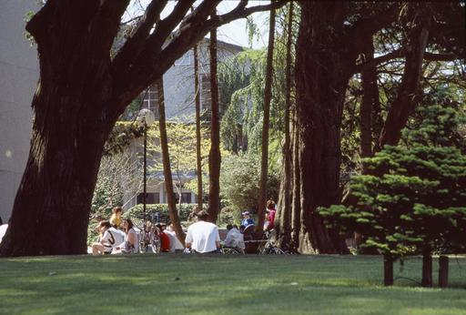

1. **DIRECTIONS TO THE MAIN CAMPUS [See Campus Map – 14]**

The main campus of UCC is half a mile west of Cork city centre, about 15 minutes’ walk along Washington Street. The College Gates on Western Road are ceremonial (foot access only): the entrance to the main campus is on College Road, and there are side entrances on Donovan’s Road, Gaol Walk and other entrances on College Road. Other UCC locations around the city tend to have a single main entrance.

There are usually plenty of taxis in the city and at the airport, rail and bus stations, but check the location of the interview and make sure you give the driver the correct address. Taxis from the city centre cost about €8. ABC Taxis (021) 4961961 and Cork Taxi Co-op (021) 4272222 are two taxi firms that operate throughout the city and surrounds.

**By Car**

From the city centre, follow the signs to Killarney and West Cork: Go west out of the city along Washington Street; go through the first two traffic lights. Pass the River Lee Hotel on your left. Turn left at the third traffic lights by the old College gates (if you are walking you can enter the campus here or through the next gates up Donovan’s Hill). Go up Donovan’s Road, past the Honan Chapel on your right; At the top of the hill, turn right onto College Road; For the main entrance to the College go 200m further down College Road, on your right.

**Parking – See Maps, Section 14**

Parking on the main campus is EXTREMELY restricted and is limited to permit holders, deliveries, those on official business and cars with disabled stickers. Other UCC

locations have very limited visitor parking particularly during term time. Some visitor parking may be found in Perrott’s Inch and Perrott Avenue car parks on an hourly charge (see separate map provided).

Perrott’s Inch car park is located on Gaol Walk and may be reached by passing the main UCC entrance on Western Road and turning left at the next traffic lights. The car park is located on the left hand side before the bridge.

To get to the Perrott Avenue car park, drive to the top of Donovan’s Road and turn right into College Road. Perrott Avenue car park will be immediately on your left. If you are driving to UCC for interview, please allow yourself plenty of time to find parking.

**By City Bus**

UCC is served by two City Bus routes (No.205 and No.208) connecting the campus to Cork City Centre via Washington and St Patrick Streets. Bus stops are located on College Road/ O’Donovan’s Road (Route No.205—about four buses each hour) and Western Road (Route No. 208—about every 15 minutes). Route No 210 buses serve Bandon Road at close walking distance to the Main Campus.

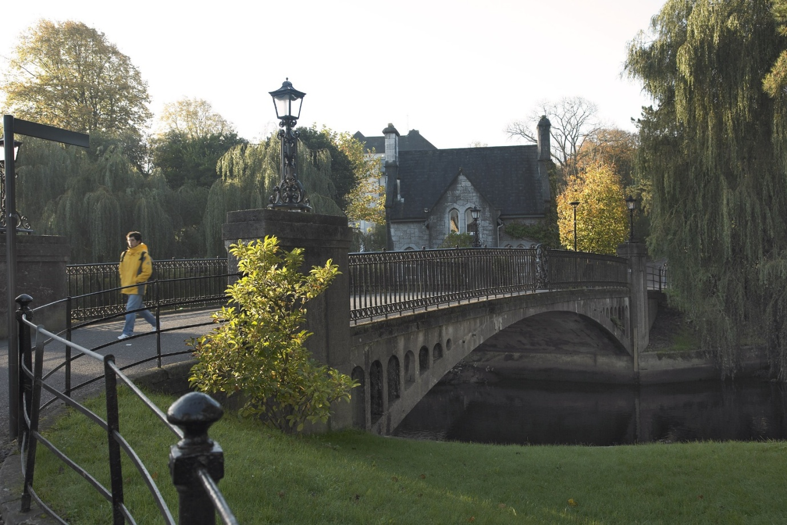

**By Train**

From Dublin (Heuston), about 8 trains a day, journey time about 3 hours. See Iarnrod Éireann’s timetables. Trains stop at Mallow for connections with Killarney, and at Limerick

Junction for connections with Limerick (for Shannon Airport). Taxis from the rail station cost about €15 and there is also a city bus meeting some trains.

**Iarnrod Éireann**

Rail Passenger Enquiries 021 4557277

[**www.irishrail.ie**](http://www.irishrail.ie)

**By long-distance bus**

From Dublin (Busaras), about 6 buses a day, journey time about 5 hours. (See Bus Éireann’s timetables.)

Taxis from the bus station cost about €12 and most city buses also stop at the bus station, which is about 300m from Patrick Street in the city centre. There is an overnight coach to and from London (Victoria Bus Station) which travels via the ferry service between Rosslare (Co Waterford) and Fishguard or Milford Haven (Wales).

**Bus Éireann** 021 4508188

Bus Station Parnell Place, Cork.

[**www.buseireann.ie**](http://www.buseireann.ie)

**By air**

Cork Airport has frequent flights to London with Aer Lingus (Heathrow and Gatwick) and RyanAir (Stanstead and Gatwick) and to a wide range of other UK and European destinations. See Cork Airport’s web site for destinations and airlines. Taxis from the airport cost about €18 and there is also an airport bus every hour during the day. All the major car rental companies have desks at the airports.

Travellers coming via Europe change at Dublin, or London where there is no direct flight to Cork (there are no flights between Cork and Dublin; see rail and bus timetables). Travellers coming via North America change at Dublin, or Shannon (there are no flights between Cork and Shannon as it is so close; see the rail and bus timetables).

**Cork Airport**

[**www.corkairport.com**](http://www.corkairport.com) 021 4313131

**Entry Visas**

People from certain countries need a valid Irish entry visa before they can land in the country. You do not need a visa to land in Ireland if you are a citizen of one of the countries listed on the following [link](http://www.foreignaffairs.gov.ie/home/index.aspx?id=8777) [**http://www.foreignaffairs.gov.ie/home/index.aspx?id=8605**](http://www.foreignaffairs.gov.ie/home/index.aspx?id=8605)

If you are not from one of the countries listed above you will require an entry visa. To apply, contact the Irish embassy or consulate in the country where you live. It may also be possible to apply online if you live in a country where the online facility is available. Please see [HERE](http://www.inis.gov.ie/en/INIS/Pages/WP07000015) for more information on applying for a visa.

Please note: The standard non-refundable visa application processing fee is €60 for a single-journey visa. This will be valid for one entry into the State within 90 days of issue. If you then wish to leave the State (this includes travel to Northern Ireland) you will then need a re-entry or multiple-entry visa to re-enter the State.

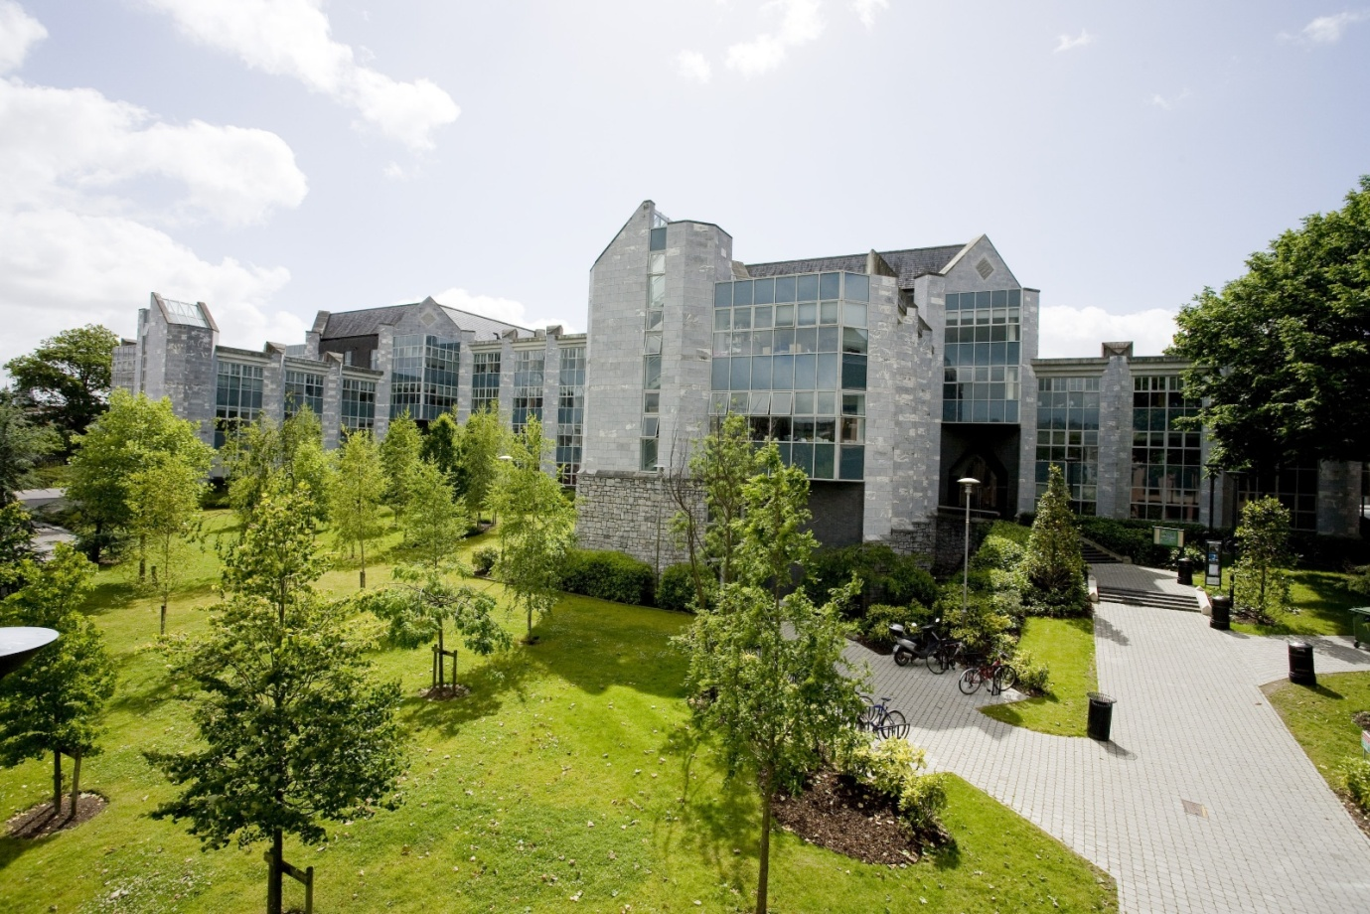

*The O’Rahilly Building, Business and Humanities*

1. **EXPENSES FOR CANDIDATES ATTENDING FOR INTERVIEW**

Candidates travelling from a distance of at least 120km outside of UCC are entitled to claim expenses for travelling to UCC, on production of original and complete receipts in accordance with the following **maximum allowance limits**:

Candidates travelling from within Ireland (including Northern Ireland) €125

Candidates travelling from Great Britain €250

Candidates travelling from mainland Europe €500

Candidates travelling from all other locations €1,200

Candidates should always choose the most economical means of travel. Public transport should be used where feasible and public transport costs at the standard class train rate will be re-imbursed, irrespective of car usage where such direct public transport exists. Full details on the candidate expenses policy can be found at: <http://www.ucc.ie/en/policiesandprocedures/humanresources/general/candidateexpenses/>



*A Tradition of Independent Thinking*

**Accommodation**

Costs of accommodation should be borne out of the allowance available as detailed. There are a number of suitable guesthouses in the vicinity of the University as follows:

Garnish House, Western Road (Tel +353 21 427 5111)

Crawford House, Western Road (Tel +353 21 427 9000)

Prices: Approximately €60 for a single room.

Further accommodation listings can be provided by the Recruitment Office. Candidates requiring assistance in booking accommodation should contact the Department of Human Resources, Recruitment Office on 021 490 3603 or e-mail: [**recruitment@ucc.ie**](mailto:recruitment@per.ucc.ie)

**Administration**

An expenses form (http://www.ucc.ie/en/media/support/hr/formbank/CandidateExpensesForm.xls) should be completed and receipts must be submitted in respect of costs claimed and should be securely attached.

Please forward the completed expenses form to the Recruitment Office for approval following interview.

Payment will be made directly into a candidate’s bank account on completion of the required bank details on the expenses form.

Expenses Claims, once submitted, will normally take a minimum of six weeks to process.

Should you have any queries concerning this expenses policy or require any further assistance or additional information, please contact the Department of Human Resources, Recruitment Office on 021 490 3603 or e-mail: [recruitment@ucc.ie](mailto:recruitment@ucc.ie)

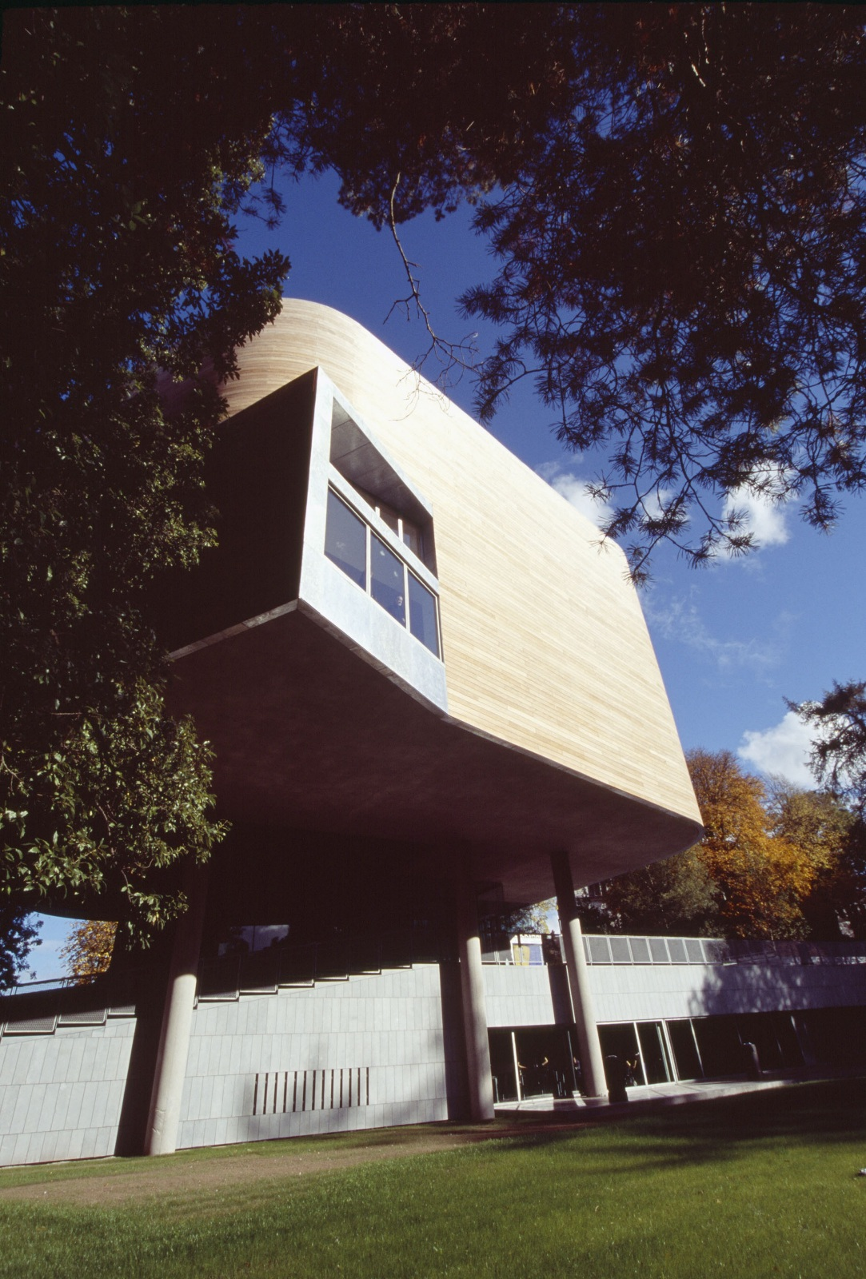

*The Glucksman Gallery*

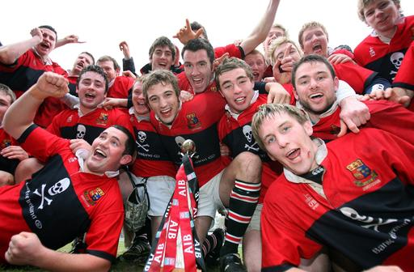

*A proud sporting tradition*

1. **CAMPUS MAPS**

**Download**:

**Main Campus Map at**: [**http://www.ucc.ie/en/media/UCC_campus_map_Edition1_2010new.pdf**](http://www.ucc.ie/en/media/UCC_campus_map_Edition1_2010new.pdf)

**Visitor Parking Map at**: [**http://www.ucc.ie/en/media/visitor-parking.pdf**](http://www.ucc.ie/en/media/visitor-parking.pdf)

**Places to Eat on Campus**: [**http://www.ucc.ie/en/media/places-to-eat.pdf**](http://www.ucc.ie/en/media/places-to-eat.pdf)

1. See also: http://www.ucc.ie/en/about/UCCHistory/
2. For alumni of UCC see: http://www.ucc.ie/en/alumni/who/